**Advance kubernetes**

<https://github.com/wardviaene/advanced-kubernetes-course.git>

**Logging in Kubernetes (Sec 2, lect 4)**

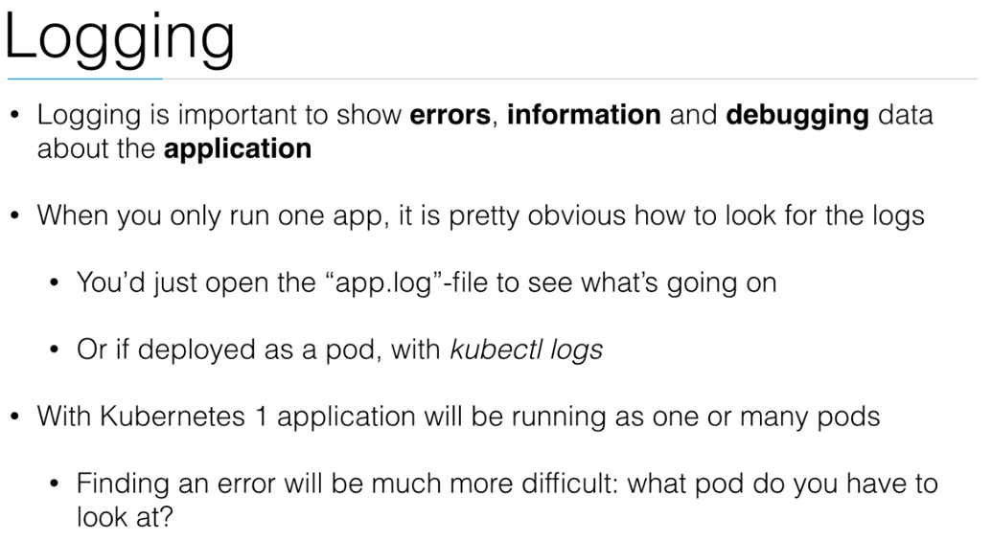

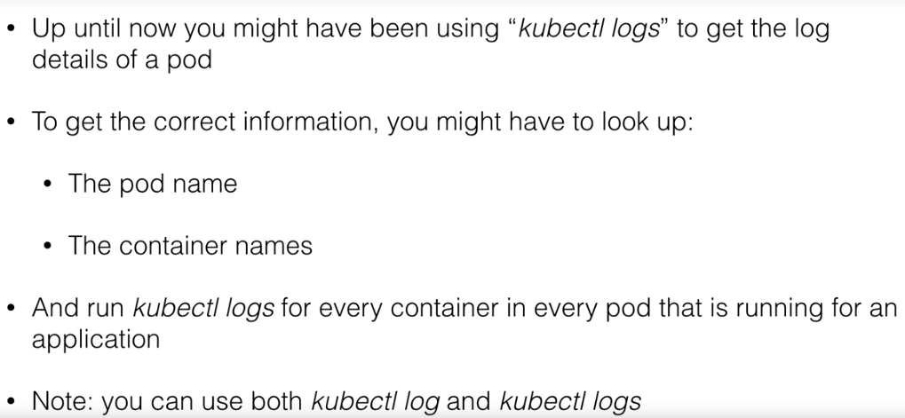

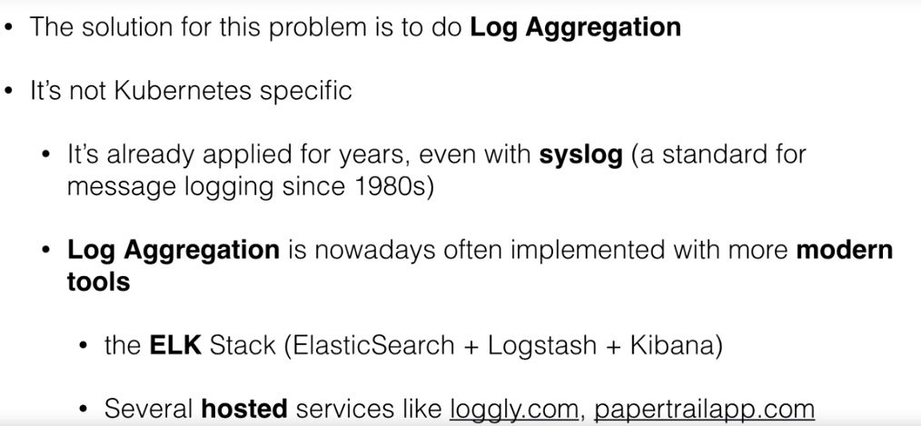

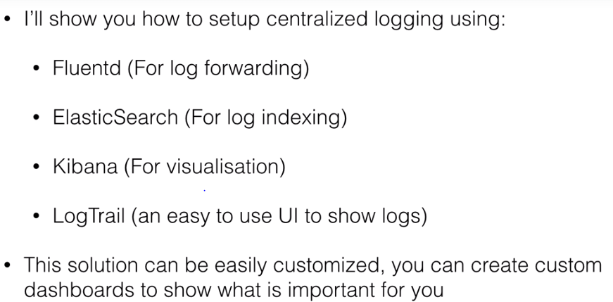

**Demo- fluentd, ES,kibana on kubernetes**